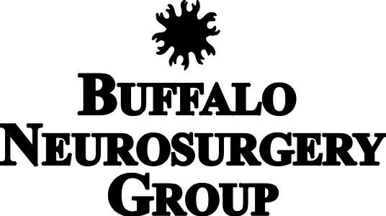

Dear Patient:
Thank you for calling our office for an appointment. We are looking forward to having you as one of our patients. Enclosed is a "Patient Data" form for you to complete. It is important that we have all of the clinical and billing information that this form requests. We ask that you fill it out before you come to the office. This will assure that we have your complete record and will reduce unnecessary waiting at the time of your visit. If your paperwork is incomplete we may have to reschedule your appointment. If you need assistance with paperwork please arrive 30 minutes before your appointment time.
Dr. Lewis is a participating member of Independent Health, Community Blue, Emblem Health, Medicare, Empire Plan, Univera, Blue Cross & Blue Shield and others. If you are required to have a referral, you must obtain a referral slip from your primary care physician and bring it with you for your appointment with us.
Dr. Lewis' policy is to collect all co-payments and deductible at the time of appointment. If surgery is necessary, any outstanding deductible must be satisfied at least one week prior to surgery.
Any cancellations of appointments must be made 24 hours before your scheduled visit.
If you had any CT, MRI scans or any x-rays taken recently, we ask that you obtain the actual films/CDs and reports and bring them with you for your office visit.
Please note that the use of cell phones or any audio or video recorders in our offices or hospitals during your encounter with our physicians and staff is strictly prohibited.
Thank you for your cooperation. If you should have any questions please call (716) 677-6000. We look forward to seeing you. (See map on reverse side of page.)
Buffalo Neurosurgery Group
P. Jeffrey Lewis, MD, FACS

550 Orchard Park Road, Suite A-105
West Seneca, New York 14224
716.677.6000 Voice
716.677.6006 Fax

ATENCIÓN: si habla español, tiene a su disposición servicios gratuitos de asistencia lingüística. Llame al 1-716-677-6000 (TTY: 1-800-676-4290).
注意：如果您使用繁體中文，您可以免費獲得語言援助服務。請致電 1-716-677-6000
P. Jeffrey Lewis, M.D. Buffalo Neurosurgery Group at Western New York Medical Park
Suite A105
90
Exit
54
N
400
Center Rd.
16
Exit
55
Buffalo Neurosurgery Group
Western New York Medical Park
Suite A105
550 Orchard Park Road West Seneca

Seneca St.
240
90
219
Harlem Rd.

From the North - Take 90 West to Exit 55 (Rt. 219). Get off at the Ridge Road - West Seneca exit.
Follow Ridge Road to Orchard Park Road. Go Left on Orchard Park Road.
We are on the Right side of Orchard Park Road about 1/4 mile from Ridge Road.
From the South - Take 90 East to Exit 55. (if using Route 400, go West on 90 at the end of the 400)
Get off at the Ridge Road - West Seneca exit. Follow Ridge Road to Orchard Park Road. Go Left on Orchard Park Road. We are on the Right side of Orchard Park Road about 1/4 mile from Ridge Road.

